Workspace Prep 1
PART 1: 1
Error Calc 4
Figures 5
%Roshan Jaiswal-Ferri
%Section - 01
%Aero 320 HW 4 - Problem 2: 10/21/24

Workspace Prep
format long %Allows for more accurate decimals
close all; %Clears all
clear all; %Clears Workspace
clc; %Clears Command Window

PART 1:
RPM300A0 = load('S2G1RPM300AOAN0.mat');
RPM300A2 = load('S2G2RPM300AOAN2.mat');
RPM300A6 = load('S2G3RPM300AOAN6.mat');
RPM300A8 = load('S3G1RPM300AOAN08.mat');
RPM300A10 = load('S3G2RPM300AOAN10.mat');
RPM300A12 = load('S3G3RPM300AOAN12.mat');
RPM200A0 = load('S4G1RPM200AOAN00.mat');
RPM200A2 = load('S4G2RPM200AOAN02.mat');
RPM200A6 = load('S4G3RPM200AOAN06.mat');
RPM200A8 = load('S5G1RPM200AOAN8.mat');
RPM200A10 = load('S5G2RPM200AOAN10.mat');
RPM200A12 = load('S5G3RPM200AOAN12.mat');
RPM150A0 = load('S6G1RPM150AOAN00.mat');
RPM150A2 = load('S6G2RPM150AOAN02.mat');
RPM150A6 = load('S6G3RPM150AOAN06.mat');
RPM150A8 = load('S7G1RPM150AOAN08.mat');
RPM150A10 = load('S7G2RPM150AOAN10.mat');
RPM150A12 = load('S7G3RPM150AOAN12.mat');
RPM300A0P = mean(RPM300A0.P);
RPM300A2P = mean(RPM300A2.P);
RPM300A6P = mean(RPM300A6.P);
RPM300A8P = mean(RPM300A8.P);
RPM300A10P = mean(RPM300A10.P);
RPM300A12P = mean(RPM300A12.P);
RPM200A0P = mean(RPM200A0.P);
RPM200A2P = mean(RPM200A2.P);
RPM200A6P = mean(RPM200A6.P);
RPM200A8P = mean(RPM200A8.P);
RPM200A10P = mean(RPM200A10.P);
RPM200A12P = mean(RPM200A12.P);
RPM150A0P = mean(RPM150A0.P);
RPM150A2P = mean(RPM150A2.P);
RPM150A6P = mean(RPM150A6.P);
RPM150A8P = mean(RPM150A8.P);
RPM150A10P = mean(RPM150A10.P);
RPM150A12P = mean(RPM150A12.P);
RPM300A0F = mean(RPM300A0.F);
RPM300A2F = mean(RPM300A2.F);
RPM300A6F = mean(RPM300A6.F);
RPM300A8F = mean(RPM300A8.F);
RPM300A10F = mean(RPM300A10.F);
RPM300A12F = mean(RPM300A12.F);
RPM200A0F = mean(RPM200A0.F);
RPM200A2F = mean(RPM200A2.F);
RPM200A6F = mean(RPM200A6.F);
RPM200A8F = mean(RPM200A8.F);
RPM200A10F = mean(RPM200A10.F);
RPM200A12F = mean(RPM200A12.F);
RPM150A0F = mean(RPM150A0.F);
RPM150A2F = mean(RPM150A2.F);
RPM150A6F = mean(RPM150A6.F);
RPM150A8F = mean(RPM150A8.F);
RPM150A10F = mean(RPM150A10.F);
RPM150A12F = mean(RPM150A12.F);
RPM300A0q = RPM300A0P(1)-RPM300A0P(2);
RPM300A2q = RPM300A2P(1)-RPM300A2P(2);
RPM300A6q = RPM300A6P(1)-RPM300A6P(2);
RPM300A8q = RPM300A8P(1)-RPM300A8P(2);
RPM300A10q = RPM300A10P(1)-RPM300A10P(2);
RPM300A12q = RPM300A12P(1)-RPM300A12P(2);
RPM200A0q = RPM200A0P(1)-RPM200A0P(2);
RPM200A2q = RPM200A2P(1)-RPM200A2P(2);
RPM200A6q = RPM200A6P(1) - RPM200A6P(2);
RPM200A8q = RPM200A8P(1) - RPM200A8P(2);
RPM200A10q = RPM200A10P(1) - RPM200A10P(2);
RPM200A12q = RPM200A12P(1) - RPM200A12P(2);
RPM150A0q = RPM150A0P(1) - RPM150A0P(2);
RPM150A2q = RPM150A2P(1) - RPM150A2P(2);
RPM150A6q = RPM150A6P(1) - RPM150A6P(2);
RPM150A8q = RPM150A8P(1) - RPM150A8P(2);
RPM150A10q = RPM150A10P(1) - RPM150A10P(2);
RPM150A12q = RPM150A12P(1) - RPM150A12P(2);
tare = load('TARE_20mps_neg30_pos20.mat');
AOA = linspace(-30,20,3673);
tareP = mean(tare.P);
q20ms = tareP(1)-tareP(2);
% figure(1)
% plot(AOA,tare.F(:,1))
% hold on
% plot(AOA,tare.F(:,2))
% hold on
% plot(AOA,tare.F(:,3))
% legend('Fx','Fy','Fz','location','best')
tare0x = -1.22;
tare0z = 0.088;
tare2x = -1.20;
tare2z = 0.072;
tare6x = -1.18;
tare6z = 0.054;
tare8x = -1.16;
tare8z = 0.058;
tare10x = -1.158;
tare10z = 0.0175;
tare12x = -1.144;
tare12z = 0.024;
tarex = [tare0x tare2x tare6x tare8x tare10x tare12x];
tarez = [tare0z tare2z tare6z tare8z tare10z tare12z];
ratiox = tarex./q20ms;
ratioz = tarez./q20ms;
rpm300q = mean([RPM300A0q RPM300A2q RPM300A6q RPM300A8q RPM300A10q RPM300A12q]);
rpm200q = mean([RPM200A0q RPM200A2q RPM200A6q RPM200A8q RPM200A10q RPM200A12q]);
rpm150q = mean([RPM150A0q RPM150A2q RPM150A6q RPM150A8q RPM150A10q RPM150A12q]);
Fsting300x = ratiox*rpm300q;
Fsting200x = ratiox*rpm200q;
Fsting150x = ratiox*rpm150q;
Fsting300z = ratioz*rpm300q;
Fsting200z = ratioz*rpm200q;
Fsting150z = ratioz*rpm150q;
forcex300 = [RPM300A0F(1) RPM300A2F(1) RPM300A6F(1) RPM300A8F(1) RPM300A10F(1) RPM300A12F(1)];
forcex200 = [RPM200A0F(1) RPM200A2F(1) RPM200A6F(1) RPM200A8F(1) RPM200A10F(1) RPM200A12F(1)];
forcex150 = [RPM150A0F(1) RPM150A2F(1) RPM150A6F(1) RPM150A8F(1) RPM150A10F(1) RPM150A12F(1)];
forcez300 = [RPM300A0F(3) RPM300A2F(3) RPM300A6F(3) RPM300A8F(3) RPM300A10F(3) RPM300A12F(3)];
forcez200 = [RPM200A0F(3) RPM200A2F(3) RPM200A6F(3) RPM200A8F(3) RPM200A10F(3) RPM200A12F(3)];
forcez150 = [RPM150A0F(3) RPM150A2F(3) RPM150A6F(3) RPM150A8F(3) RPM150A10F(3) RPM150A12F(3)];
D300 = 4.448*(forcex300 - Fsting300x);
D200 = 4.448*(forcex200 - Fsting200x);
D150 = 4.448*(forcex150 - Fsting150x);
L300 = 4.448*(forcez300 - Fsting300z);
L200 = 4.448*(forcez200 - Fsting200z);
L150 = 4.448*(forcez150 - Fsting150z);
Sref = 0.670*0.115;
CD300 = D300./(Sref*rpm300q);
CD200 = D200./(Sref*rpm200q);
CD150 = D150./(Sref*rpm150q);
CL300 = L300./(Sref*rpm300q);
CL200 = L200./(Sref*rpm200q);
CL150 = L150./(Sref*rpm150q);
r = 0.115;
rhoinf = 1.225;
uinf300 = sqrt(2*rpm300q/rhoinf);
uinf200 = sqrt(2*rpm200q/rhoinf);
uinf150 = sqrt(2*rpm150q/rhoinf);
muinf = 1.789e-5;
Re300 = rhoinf*uinf300*2*r/muinf;
Re200 = rhoinf*uinf200*2*r/muinf;
Re150 = rhoinf*uinf150*2*r/muinf;
AOA = [0 2 6 8 10 12];
AOAlinspace = linspace(0,12,100);
coefL150 = polyfit(AOA,CL150,3);
yl150 = polyval(coefL150,AOAlinspace);
coefL200 = polyfit(AOA,CL200,3);
yl200 = polyval(coefL200,AOAlinspace);
coefL300 = polyfit(AOA,CL300,3);
yl300 = polyval(coefL300,AOAlinspace);
coefD150 = polyfit(AOA,CD150,3);
yD150 = polyval(coefD150,AOAlinspace);
coefD200 = polyfit(AOA,CD200,3);
yD200 = polyval(coefD200,AOAlinspace);
coefD300 = polyfit(AOA,CD300,3);
yD300 = polyval(coefD300,AOAlinspace);
for i = 1:length(CL300)
CDL300(i) = CL300(i)/CD300(i);
CDL200(i) = CL200(i)/CD200(i);
CDL150(i) = CL150(i)/CD150(i);
end

Error Calc
sigCL150 = sqrt(((1/rpm150q*Sref)^2)+((L150./(Sref*(rpm150q^2))).^2));
sigCL200 = sqrt(((1/rpm200q*Sref)^2)+((L200./(Sref*(rpm200q^2))).^2));
sigCL300 = sqrt(((1/rpm300q*Sref)^2)+((L300./(Sref*(rpm300q^2))).^2));
sigCD150 = sqrt(((1/rpm150q*Sref)^2)+((D150./(Sref*(rpm150q^2))).^2));
sigCD200 = sqrt(((1/rpm200q*Sref)^2)+((D200./(Sref*(rpm200q^2))).^2));
sigCD300 = sqrt(((1/rpm300q*Sref)^2)+((D300./(Sref*(rpm300q^2))).^2));
sigClCd150 = sqrt((((1./CD150).*sigCL150).^2)+(((CL150./(CD150.^2)).*sigCD150).^2));
sigClCd200 = sqrt((((1./CD200).*sigCL200).^2)+(((CL200./(CD200.^2)).*sigCD200).^2));
sigClCd300 = sqrt((((1./CD300).*sigCL300).^2)+(((CL300./(CD300.^2)).*sigCD300).^2));

Figures
figure(1)
plot(AOA,CD150)
hold on
errorbar(AOA, CD150, sigCL150, 'HandleVisibility', 'off')
plot(AOA,CD200)
errorbar(AOA, CD200, sigCL200, 'HandleVisibility', 'off')
plot(AOA,CD300)
errorbar(AOA, CD300, sigCL300, 'HandleVisibility', 'off')
xlabel('Angle of Attack (deg)')
ylabel('Coefficient of Drag')
title('AOA vs Coefficient of Drag NACA 4412')
legend('Re = 56,140', 'Re = 81,890','Re = 130,010','location','northwest')
figure(2)
plot(AOA,CL150)
hold on
errorbar(AOA, CL150, sigCD150, 'HandleVisibility', 'off')
plot(AOA,CL200)
errorbar(AOA, CL200, sigCD200, 'HandleVisibility', 'off')
plot(AOA,CL300)
errorbar(AOA, CL300, sigCD300, 'HandleVisibility', 'off')
xlabel('Angle of Attack (deg)')
ylabel('Coefficient of Lift')
title('AOA vs Coefficient of Lift NACA 4412')
legend('Re = 56,140', 'Re = 81,890','Re = 130,010','location','best')
figure(3)
plot(AOA, CDL150)
hold on
errorbar(AOA, CDL150, sigClCd150, 'o', 'HandleVisibility', 'off')
plot(AOA, CDL200)
errorbar(AOA, CDL200, sigClCd200, 'o', 'HandleVisibility', 'off')
plot(AOA, CDL300)
errorbar(AOA, CDL300, sigClCd300, 'o', 'HandleVisibility', 'off')
xlabel('Angle of Attack (deg)')
ylabel('Cl/Cd')
title('AOA vs Cl/Cd NACA 4412')
legend('Re = 56,140', 'Re = 81,890', 'Re = 130,010', 'location', 'best')
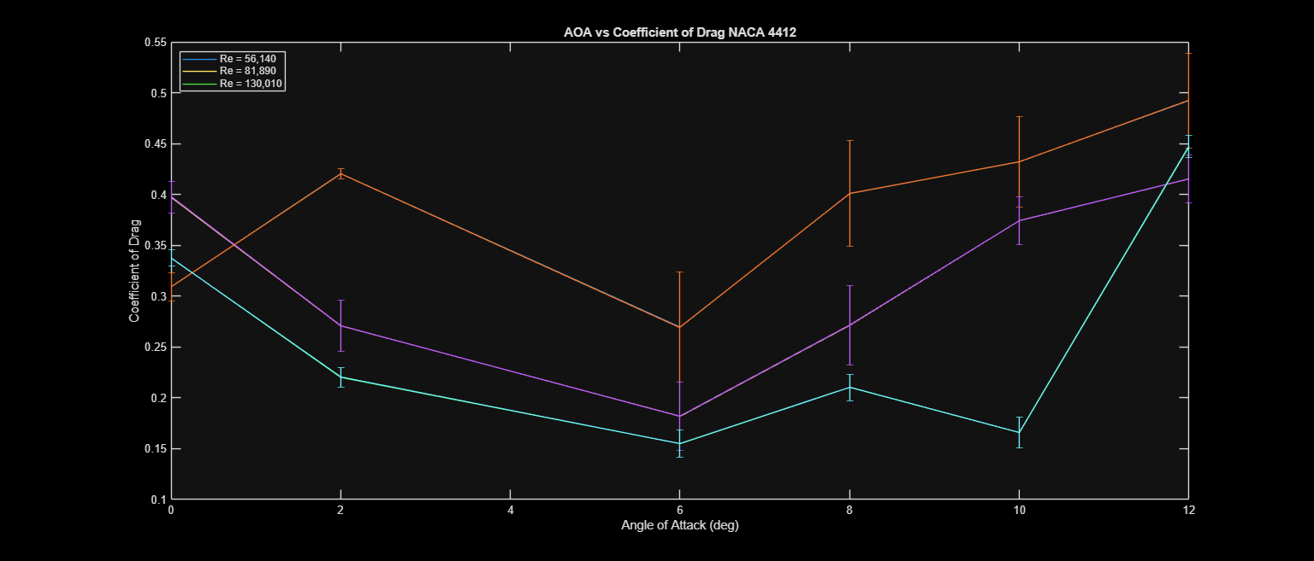
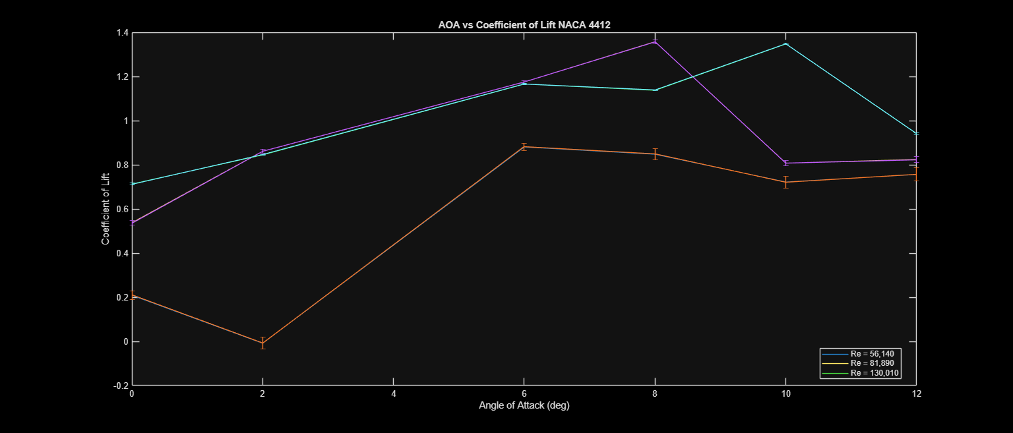
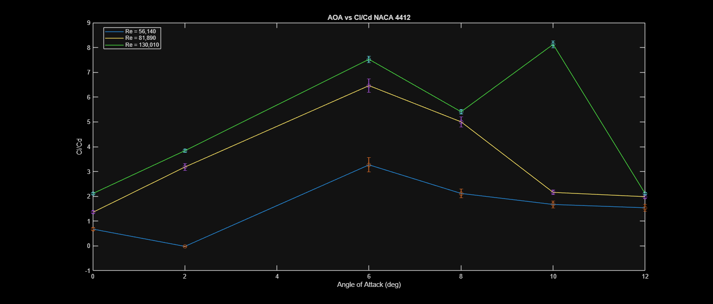
Published with MATLAB® R2024b

